|  |  |
| --- | --- |
| **NAME:** | Bodhisatya Ghosh |
| **UID:** | 2021700026 |
| **BRANCH:** | T.Y. CSE Data Science |
| **BATCH:** | B |
| **SUBJECT:** | FOSIP |
| **EXP. NO.:** | 7 |

**AIM: -** Study Image Enhancement using Spatial Filtering

# OBJECTIVES:

1. Image Enhancement using Spatial Filtering based on recent published technique based
2. Download the research paper from IEEE Xplorer published after 2018
3. Develop the algorithm and process the following types of images
   1. Low Contrast Photograph (Your Picture)
   2. Raw X-Ray Image
   3. Raw Satellite Image downloaded from standard database
4. Evaluate the efficiency of algorithm using Objective Evaluation Test and Subjective evaluation Test.
5. Give your conclusion based on results obtained.

# INTRODUCTION:

Spatial filters are convolution kernels that are used to perform operations like blurring, sharpening, and edge detection on images. Here are examples of full spatial filters for three common operations: smoothing (low-pass filter), sharpening (high-pass filter), and edge detection.

* 1. Low-Pass (Smoothing) Filter (Gaussian Filter):
     + A Gaussian filter is commonly used for smoothing and noise reduction.
     + Gaussian Kernel:

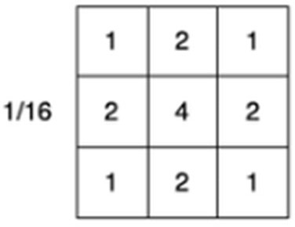

* 1. High-Pass Filter (Laplacian Filter):
     + The Laplacian filter enhances edges and details in an image.
     + Laplacian Kernel:

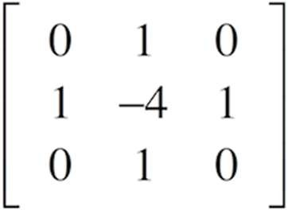

* 1. Edge Detection (Sobel Operator):
     + The Sobel operator is commonly used for edge detection.

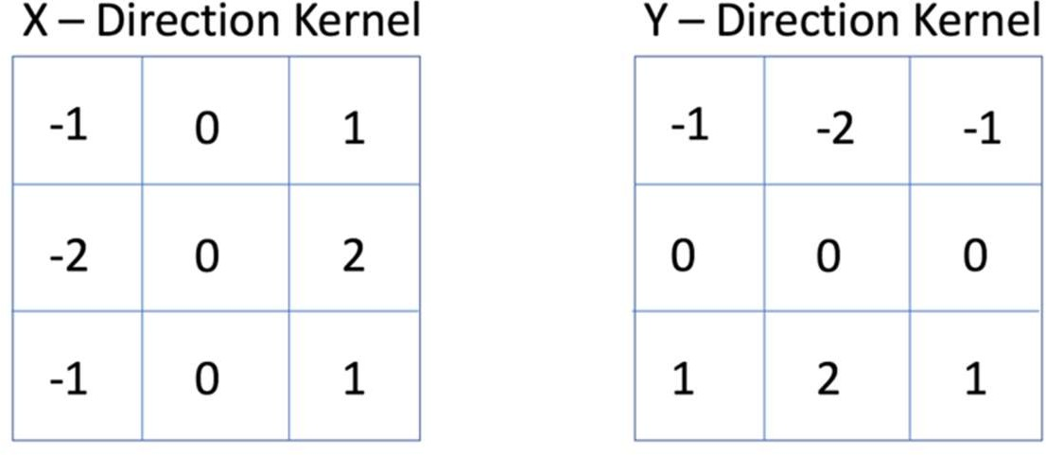

# EXPERIMENTATION:

**CODE:**

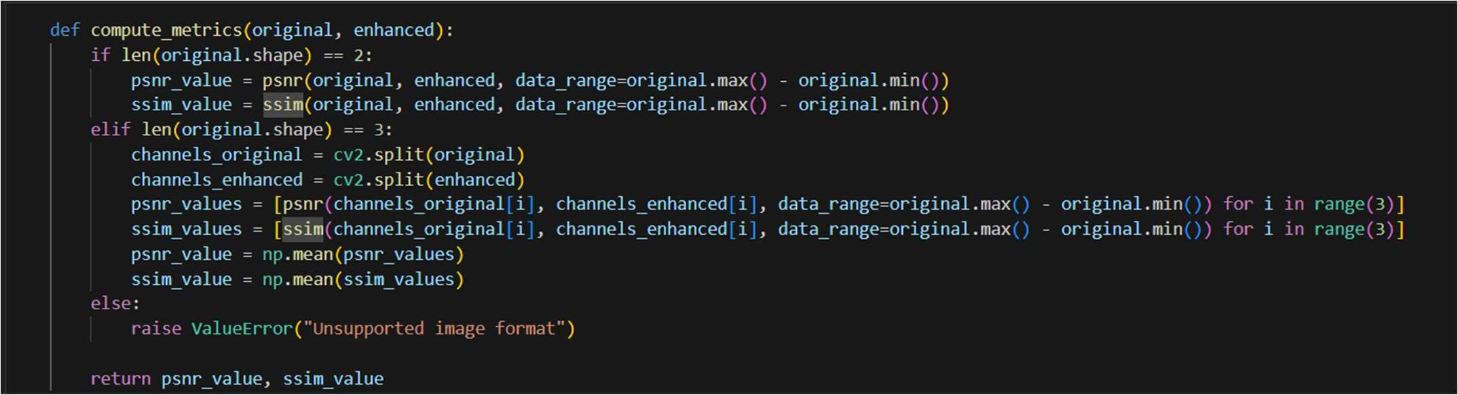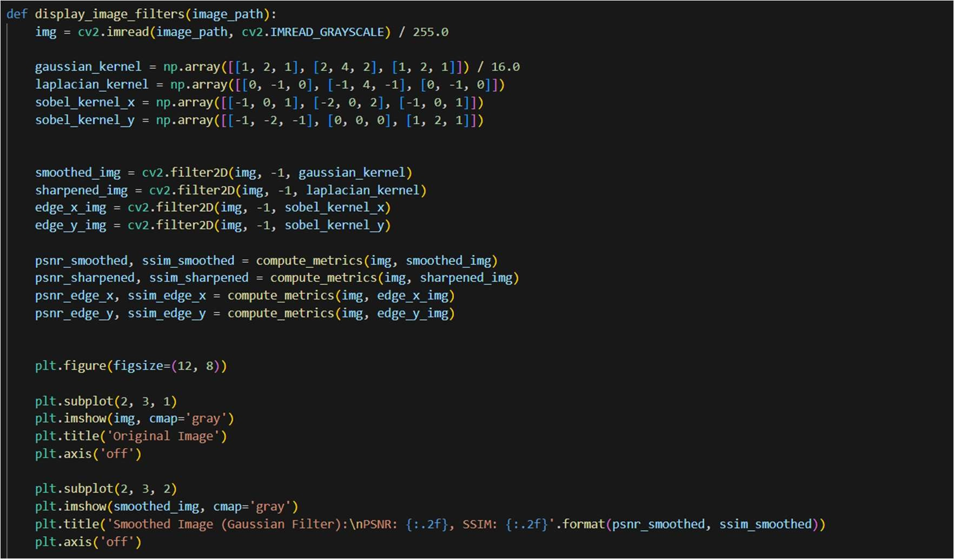

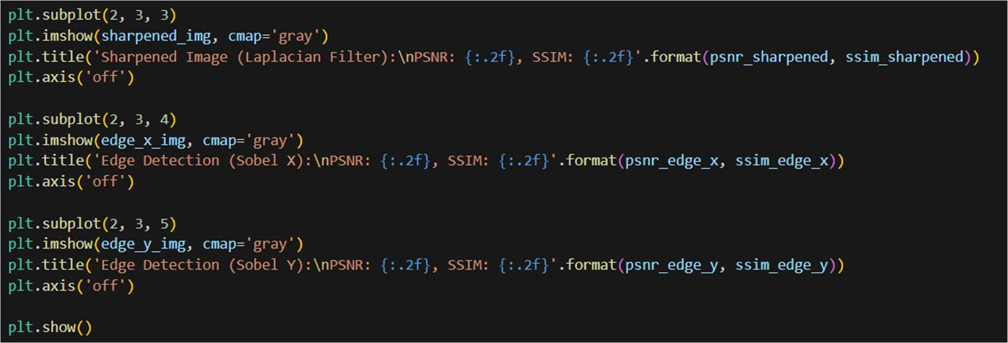

# RESULT:

1. My Picture

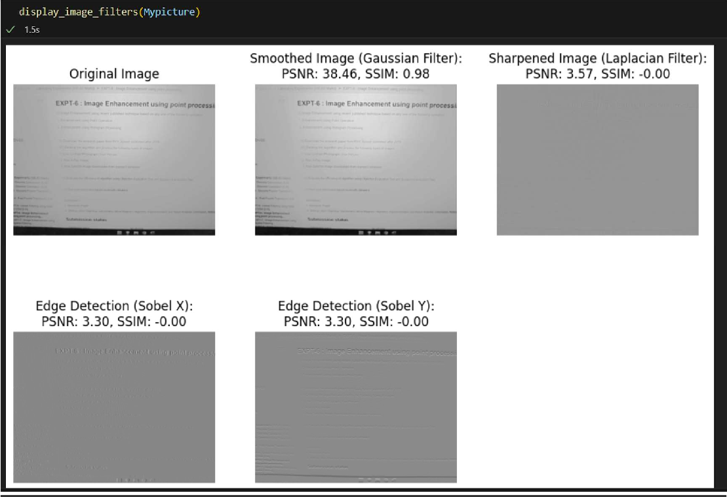

1. Raw X-Ray

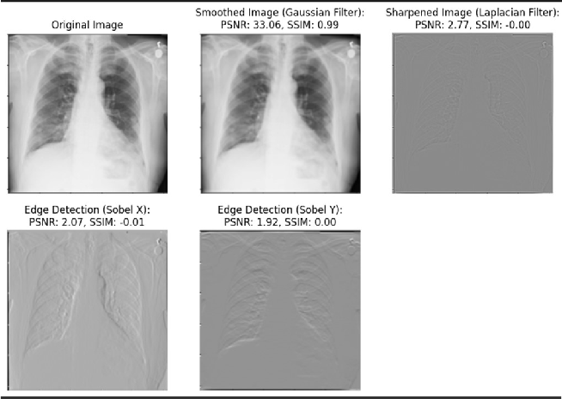

1. Satellite Image

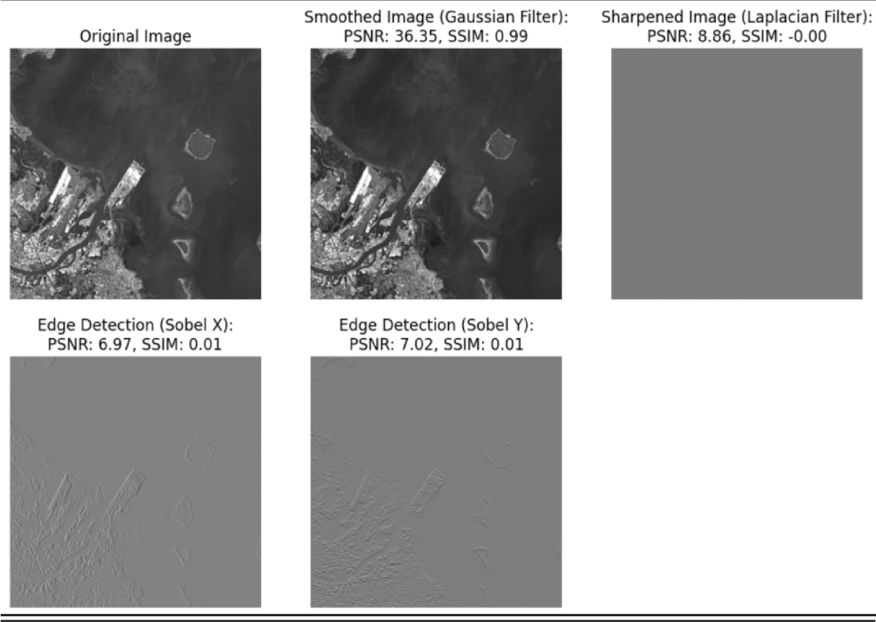

# CONCLUSION:

* 1. Successfully performed image enhancement using spatial filtering.
  2. Gaussian Filter showed good results.